**RAJALAKSHMI ENGINEERING COLLEGE**

**RAJALAKSHMI NAGAR, THANDALAM – 602 105**



| **CS23221**  **PYTHON PROGRAMMING LAB** |
| --- |
| **Laboratory Observation Note Book** |

# 

**10 - Searching & Sorting**

**Ex. No. : 10.1 Date:** 25/5/24

**Register No.: 231501048 Name: Girivasanth V**



**Merge Sort**

Write a Python program to sort a list of elements using the merge sort algorithm.

**For example:**

| **Input** | **Result** |
| --- | --- |
| 5  6 5 4 3 8 | 3 4 5 6 8 |

**PROGRAM**

a = int(input())

b = list(input().split(" "))

b.sort()

for i in b:

print(i,end=" ")

**OUTPUT:**

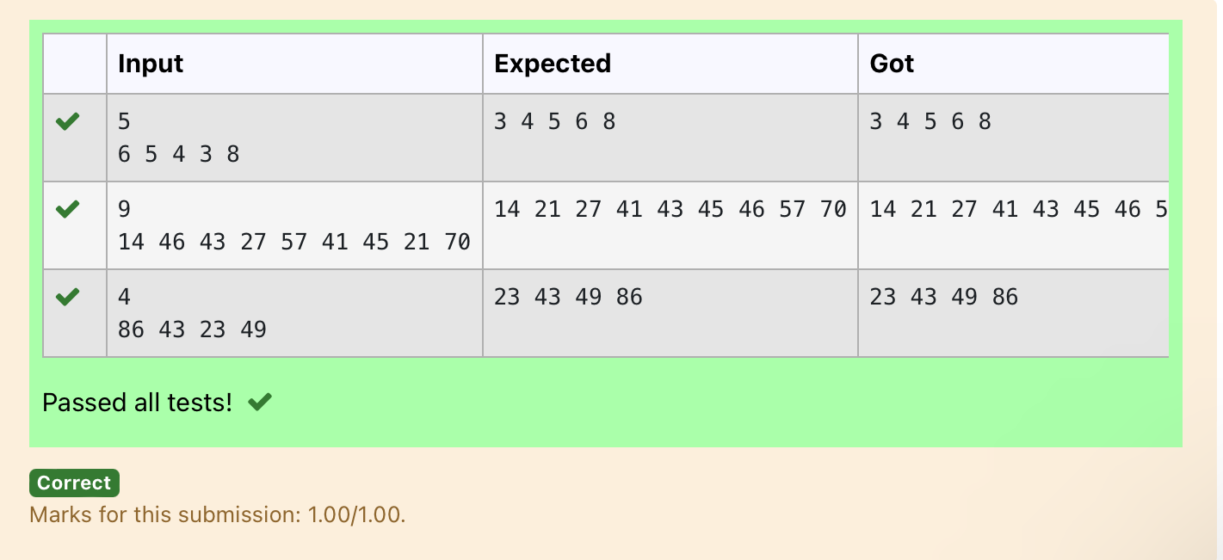

**Ex. No. : 10.2 Date:** 25/5/24

**Register No.: 231501048 Name: Girivasanth V**



**Bubble Sort**

Given an listof integers, sort the array in ascending order using the *Bubble Sort* algorithm above. Once sorted, print the following three lines:

1.      [List](http://118.185.187.137/moodle/mod/resource/view.php?id=1068) is sorted in numSwaps swaps., where numSwaps is the number of swaps that took place.

2.      First Element: firstElement, the  *first* element in the sorted [list](http://118.185.187.137/moodle/mod/resource/view.php?id=1068).

3.      Last Element: lastElement, the *last* element in the sorted [list](http://118.185.187.137/moodle/mod/resource/view.php?id=1068).

For example, given a worst-case but small array to sort: a=[6,4,1]. It took  3 swaps to sort the array. Output would be

Array is sorted in 3 swaps.

First Element: 1

Last Element: 6

**Input Format**

The first line contains an integer,n , the size of the [list](http://118.185.187.137/moodle/mod/resource/view.php?id=1068) a .  
The second line contains  n,  space-separated integers a[i].

**Constraints**

·         2<=n<=600

·         1<=a[i]<=2x106.

**Output Format**

You must print the following three lines of output:

1.      [List](http://118.185.187.137/moodle/mod/resource/view.php?id=1068) is sorted in numSwaps swaps., where numSwaps is the number of swaps that took place.

2.      First Element: firstElement, the  *first* element in the sorted [list](http://118.185.187.137/moodle/mod/resource/view.php?id=1068).

3.      Last Element: lastElement, the *last* element in the sorted [list](http://118.185.187.137/moodle/mod/resource/view.php?id=1068).

**Sample Input 0**

3

1 2 3

**Sample Output 0**

[List](http://118.185.187.137/moodle/mod/resource/view.php?id=1068) is sorted in 0 swaps.

First Element: 1

Last Element: 3

**For example:**

| **Input** | **Result** |
| --- | --- |
| 3  3 2 1 | List is sorted in 3 swaps.  First Element: 1  Last Element: 3 |
| 5  1 9 2 8 4 | List is sorted in 4 swaps.  First Element: 1  Last Element: 9 |

**PROGRAM**

num = 0

a = int(input())

b = input().split(" ")

c = []

for i in range(len(b)):

c.append(int(b[i]))

for j in range(len(c)):

for i in range(len(c)-1):

if c[i] > c[i+1]:

c[i], c[i+1] = c[i+1], c[i]

num += 1

print(f"List is sorted in {num} swaps.\nFirst Element: {c[0]}\nLast Element: {c[-1]}")

OUTPUT:

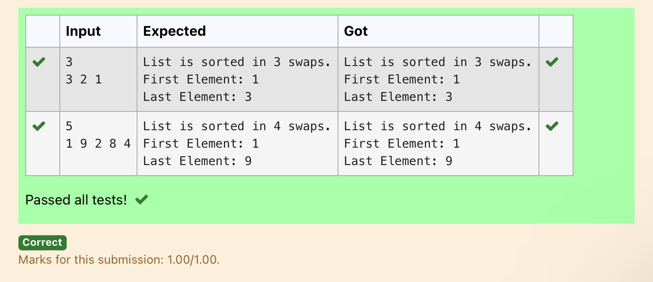

**Ex. No. : 10.3 Date:** 25/5/24

**Register No.: 231501048 Name: Girivasanth V**



**Peak Element**

Given an [list](http://118.185.187.137/moodle/mod/resource/view.php?id=1068), find peak element in it. A peak element is an element that is greater than its neighbors.

An element a[i] is a peak element if

A[i-1] <= A[i] >=a[i+1] for middle elements. [0<i<n-1]

A[i-1] <= A[i] for last element [i=n-1]

A[i]>=A[i+1] for first element [i=0]

**Input Format**

The first line contains a single integer n , the length of A .  
The second line contains n space-separated integers,A[i].

**Output Format**

**Print** peak numbers separated by space.

**Sample Input**

| **Input** | **Result** |
| --- | --- |
| 4  12 3 6 8 | 12 8 |

5

8 9 10 2 6

**Sample Output**

10 6

**For example:**

**PROGRAM**

n = int(input())

A = list(map(int, input().split()))

if n == 1:

print(A[0])

else:

if A[0] >= A[1]:

print(A[0], end=" ")

for i in range(1, n - 1):

if A[i] >= A[i - 1] and A[i] >= A[i + 1]:

print(A[i], end=" ")

if A[n - 1] >= A[n - 2]:

print(A[n - 1])

**OUTPUT:**

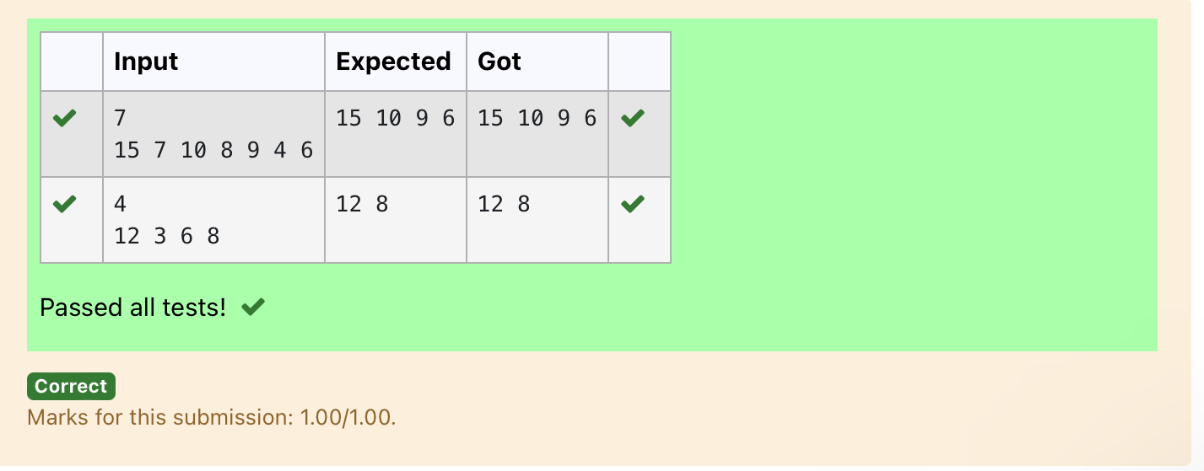

**Ex. No. : 10.4 Date:** 25/5/24

**Register No.: 231501048 Name: Girivasanth V**



**Binary Search**

Write a Python program for binary search.

**For example:**

| **Input** | **Result** |
| --- | --- |
| 1 2 3 5 8  6 | False |
| 3 5 9 45 42  42 | True |

**PROGRAM**

def binary_search(arr, x):

left, right = 0, len(arr) - 1

while left <= right:

mid = (left + right) // 2

if arr[mid] == x:

return True

elif arr[mid] < x:

left = mid + 1

else:

right = mid - 1

return False

arr = list(map(int, input().split(',')))

x = int(input())

arr.sort()

result = binary_search(arr, x)

print(result)

**OUTPUT:**

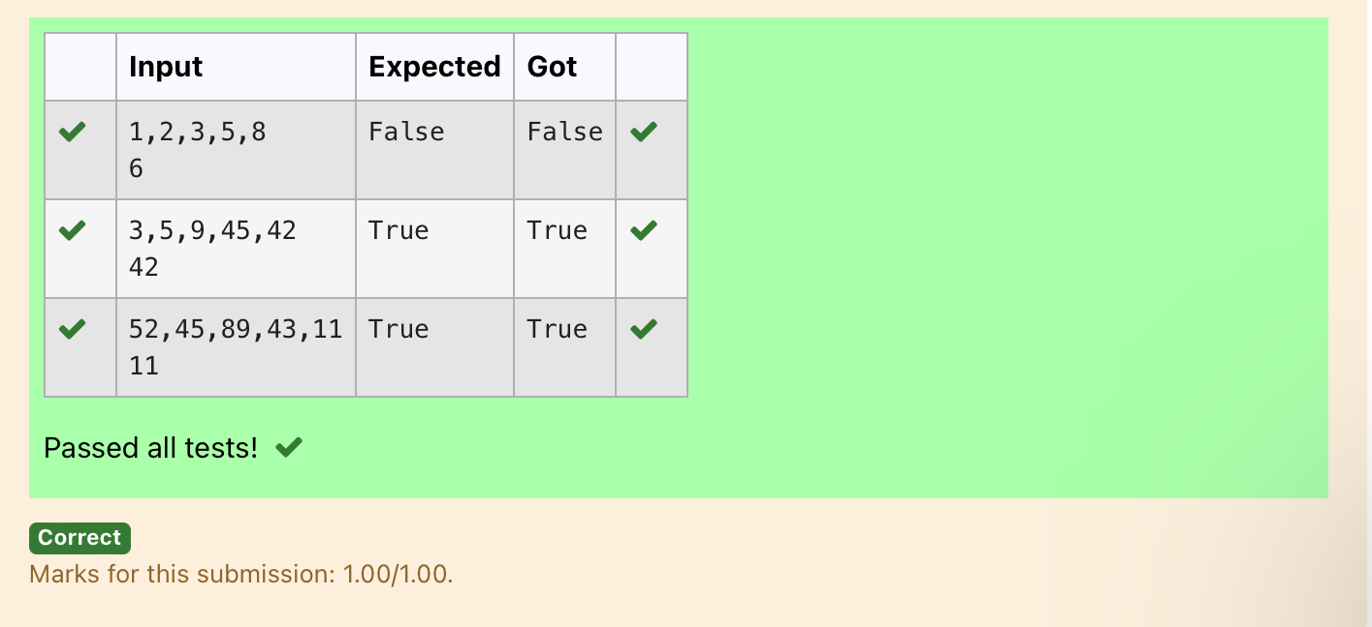

**Ex. No. : 10.5 Date:** 25/5/24

**Register No.: 231501048 Name: Girivasanth V**



**Frequency of Elements**

To find the frequency of numbers in a list and display in sorted order.

**Constraints:**

1<=n, arr[i]<=100

**Input:**

1 68 79 4 90 68 1 4 5

**output:**

 1 2

 4 2

 5 1

 68 2

 79 1

90 1

**For example:**

| **Input** | **Result** |
| --- | --- |
| 4 3 5 3 4 5 | 3 2  4 2  5 2 |

**PROGRAM**

numbers = input().split()

numbers = [int(num) for num in numbers]

frequency = {}

for num in numbers:

if num in frequency:

frequency[num] += 1

else:

frequency[num] = 1

sorted_frequency = sorted(frequency.items())

for key, value in sorted_frequency:

print(key, value)

**OUTPUT:**

